**Project Description:**

MasSafe is a Finance Management Mobile Application. Users will be asked to create a profile for their personal use. The main page of the application will contain the user's current balance alongside the banks they frequently use. Their card information will also be used. The use of Cash-in/Cash-out methods such as Gcash and Paymaya will also be implemented. They will also be supplied with a history of their transactions, containing date, amount, bank used, and location of transaction.

**Requirements Summary:**

|  |  |  |
| --- | --- | --- |
| **Minimum Requirements** | Processor Cores | **Dual-Core (A9+ Chip)** |
| OS | **Ios 12+** |
| RAM | **2 GB** |
| **Recommended Requirements** | Processor Cores | **Quad-Core (A12+ Bionic Chip)** |
| OS | **Ios 15+** |
| RAM | **4GB+** |
| **Other Requirements** | **Permissions** | **Notifications and Storage** |

***Table 1. System Requirements***

The minimal prerequisites for a banking transaction iOS mobile app are a dual-core CPU (A9 chip), iOS 12, and 2GB of RAM. To ensure the best performance and security, a quad-core CPU (A12 Bionic chip), iOS 15, and 4 GB or more of RAM are recommended.

**Prototype Description**

The prototype used was created in Figma. We decided to use Figma because of its interactivity, making teamwork easier alongside communication. Also, the website is good for testing and is easy to share and distribute with people who may be interested in our product.

**MasSafe Figma Link:**

https://www.figma.com/design/PfzCK0Ngwa3fWRz10P3sOM/MasSafe-Prototype?node-id=0-1&t=TGH5ZB6Tyabe7pfh-0

**User Scenario:**

A user wants to find a mobile bank transaction app that has good security and will aid him in performing several tasks, such as creating an account, bank transfers, store credit card information, display a history of his transactions, and the most important, connectivity to GCash and Paymaya. He saw an ad for an app named “MasSafe” and it caught his eye, so he downloaded it and began using it. Shortly after, he was using it daily and recommending it to other people.

**MasSafe Mock-up/Prototype:**

**

**Transfers Page Card Transfer Page QR Generation Page**

**Profile Page**

**Prototype Flow**

**Main Screen:**

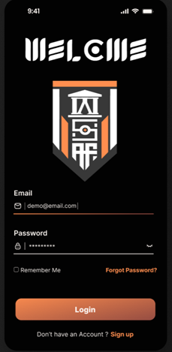 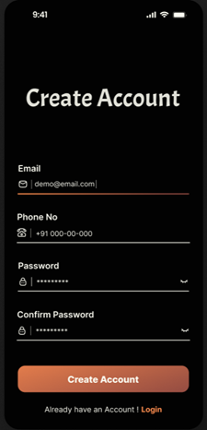

**Transfers Screen:**

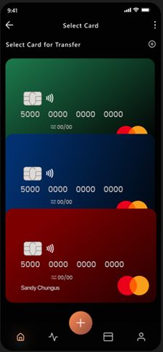 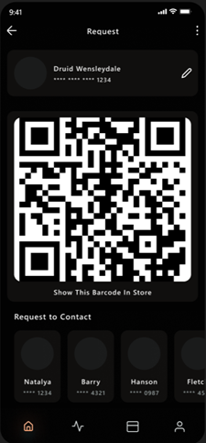

**Login to Profile Page**



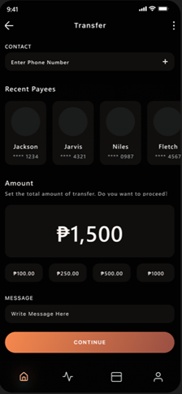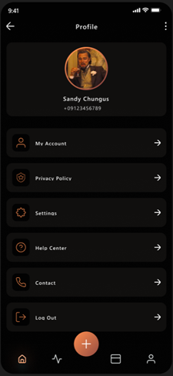****





**Rationale:**

MasSafe seeks to improve personal finance management by providing users with a full perspective of their financial activity. The software improves financial transparency and ease by making current balances, commonly used banks, and card information readily available. Integrating popular cash-in/cash-out options such as Gcash and Paymaya provides greater flexibility in managing monies. Furthermore, the complete transaction history, which includes the date, amount, bank, and location, helps customers track their spending habits and maintain financial discipline.

**Changes to Requirements:**

To improve user experience and future-proof the software, changing the minimum CPU requirement to a quad-core (A12 Bionic chip) and updating the operating system to iOS 14 would be useful. Increasing the minimum RAM requirement to 3 GB would result in better performance, particularly given the app's huge transaction history and various connectors. For the required requirements, an A14 Bionic chip with iOS 16 and 6 GB of RAM would enhance the app's performance and security. These improvements will let the app incorporate more advanced features while also ensuring its efficiency across a larger range of devices.

**Initial Evaluation Plan:**

The initial evaluation strategy for MasSafe would include user testing with a varied set of people to analyze the app's usability, performance, and functionality. This would involve obtaining comments on the convenience of creating a profile, navigating the main website, and the usefulness of cash-in/cash-out mechanisms such as Gcash and Paymaya. Performance measures, such as load times and responsiveness, would be evaluated in conjunction with security evaluations to assure data security. Furthermore, reviewing the transaction history features clarity and effectiveness would aid in identifying areas for improvement prior to its final deployment.

**Participation Survey and Feedback:**

|  |  |
| --- | --- |
| **Questions** | **Method of Answer** |
| Rate the UI of our application. | 5 Point Scale |
| Is the interface easy to understand? |
| Rate the organization of our application. |
| Welcome Page UI |
| Registration UI |
| Home Page UI |
| Transfers UI |
| QR Code UI |
| Profile UI |

**Link for Google Forms (Data Gathering):**

|  |  |  |  |
| --- | --- | --- | --- |
| **Scale** | **Range Value** | **Interpretation** | **Classification** |
| 5 | 4.50-5 | Very Satisfiable | Accepted |
| 4 | 3.50-4.49 | Satisfiable | Accepted |
| 3 | 2.50-3.49 | Moderately Satisfiable | Neutral |
| 2 | 1.50-2.49 | Poorly Satisfiable | Not Accepted |
| 1 | 1.00-1.49 | Not Accepted | Not Accepted |